You may only be able to celebrate with six people and you might have to do all your shopping online, but don’t worry because we are celebrating in style with The 12 Days of Christmas. Get ready for treats and gifts galore, celebrating the festive period like never before, because at Hucknall National Primary School, Christmas is going viral!
1. On the 1st day of Christmas, National gave to me… | December 3rd  Santa arrives in Hucknall and big Christmas lights switch-on
2. On the 2nd day of Christmas, National gave to me… | December 4th  Christmas window art  Make some art to take home and stick in your window to spread the Christmas cheer and for people to admire on their festive walks around Hucknall.
3. On the 3rd day of Christmas, National gave to me… | December 7th  Letters to Santa
4. On the 4th day of Christmas, National gave to me… | December 8th  National Christmas message  Including special appearances from Boris Johnson, Her Majesty the Queen and a special performance from the teachers.
5. On the 5th day of Christmas, National gave to me… | December 9th  Christmas jumper/non-uniform day for charity
6. On the 6th day of Christmas, National gave to me… |   December 10th  Make a Christmas card for someone in your class  We are not accepting Christmas cards in school this year so each child will make a card in class for a friend and one to take home.
7. On the 7th day of Christmas, National gave to me… |   December 11th  Christmas pantomime
8. On the 8th day of Christmas, National gave to me… | December 14th  Visit from Santa
9. On the 9th day of Christmas, National gave to me… | December 15th  Watch the school nativity
10. On the 10th day of Christmas, National gave to me… | December 16th  Christmas dinner day, including extra  special festive packed lunches!
11. On the 11th day of Christmas, National gave to me… | December 17th  Christmas parties
12. On the 12th day of Christmas, National gave to me… | December 18th  Christmas film
Our Head Boy and Head Girl will be picking a name out of a hat to receive a FREE Christmas gift.
There will be Christmas Choir Carols on the drive at home time.
Random acts of kindness will be taking place every day.


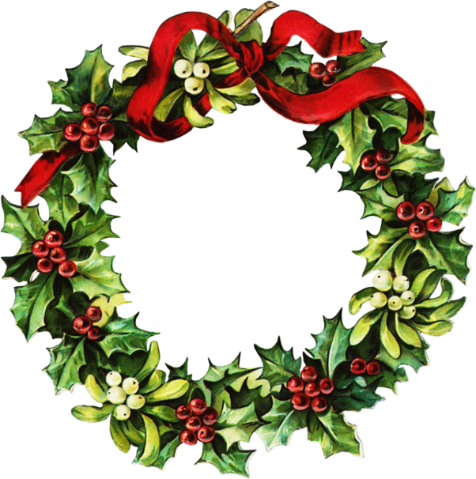
The 12
Days of
Christmas

